
Student Registration at Certiport

Prior to student’s registering, they will need their student ID number.

Go to: www.certiport.com; Click on Register and follow the prompts.



Tip 1: The student’s name must be spelled accurately including capitalization. This field cannot be changed. When the certificate is printed the name will appear exactly as it was entered.

Tip 2: Username: Use something that will be remembered easily. If the username has been previously used, you will be prompted to use something different. This username will be entered in prior to taking an exam. This field cannot be changed.

Tip 3: Password: Use something that will be remembered easily. Passwords can be changed at a later date.

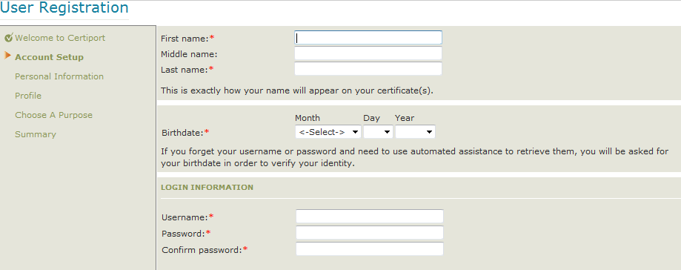

Tip 4: E-mail: This is a required field. If student does not have an e-mail address, have them create a free account with google, hotmail or use their parent’s e-mail or last resort they may use the teachers (not recommended). The e-mail is used after the student registers, receiving their welcome letter with their user name and password. It is also used to send a congratulation letter when they pass their certification.

Tip 5: Student/Employee ID: This is not a required field from Certiport, however, it is a requirement asked by the state.

Tip 6: Have the student unclick the “All Certiport to contact me via e-mail…..”

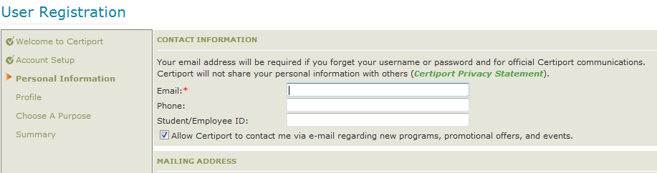
Tip 7: After clicking “Take an exam or prepare for an exam” students will be asked to register a program. Once they register for Microsoft, a screen for Microsoft registration will appear. Have the student select “use my Certiport profile data: and the information will populate the fields.
Tip 8: Have the student fill out the below. Student keeps their half for their records and have readily available when they are ready to take the exam, and have them hand you (the teacher) the other half for record keeping in case the student loses their information.
Contact Certiport at 888.999.9830 option 9, for questions

For Student | For Teacher
Student Name | Student Name
User Name | User Name
Password: | Password:

.

