**OnBase Web Client Setup and Access OTS instructions**

1. Go to the following web site to login LEADS Application Portal to download and install the Hyland ActiveX Control software on your computer.

<https://leads3.doe.louisiana.gov/ptl>

Once you login LEADS Application Portal, the following screen will display.  You then click on “OnBase – Hyland ActiveX Control software installer” under ADDITIONAL LINKs on the right-hand side of this screen to install the Hyland ActiveX Control software.

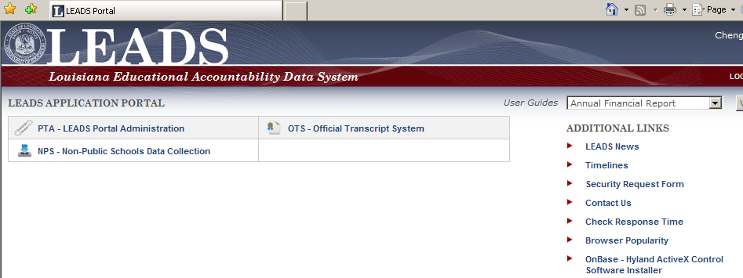

**P.S. You might need your IT person to do this for you because you might not have privilege to install software on your computer**.

After this new software is installed, you **must close** LEADS Application Portal screen, login LEADS Application Portal again, and then click on “OTS – Official Transcript System” link to pop up the new OnBase login screen as shown below

2. Open Internet Explorer, click Tools icon on tool bar and turn off POP-Up blocker.  Go to the above web site and login LEADS Application Portal again.  Click the OTS – Official Transcript System to login OTS. to retrieve transcripts by keying in known keywords and clicking on.

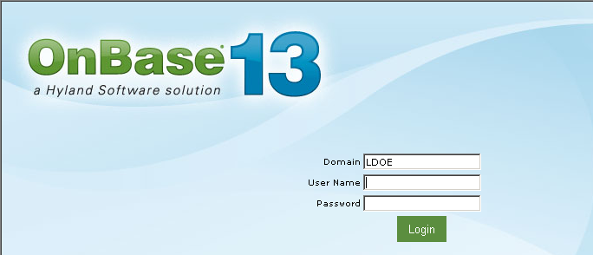

3. Click on Custom Queries under Document and click on “SSAA – HS Transcript” under Custom Queries to display keyword boxes for data entries. Key in keywords and click on binocular to retrieve transcripts.

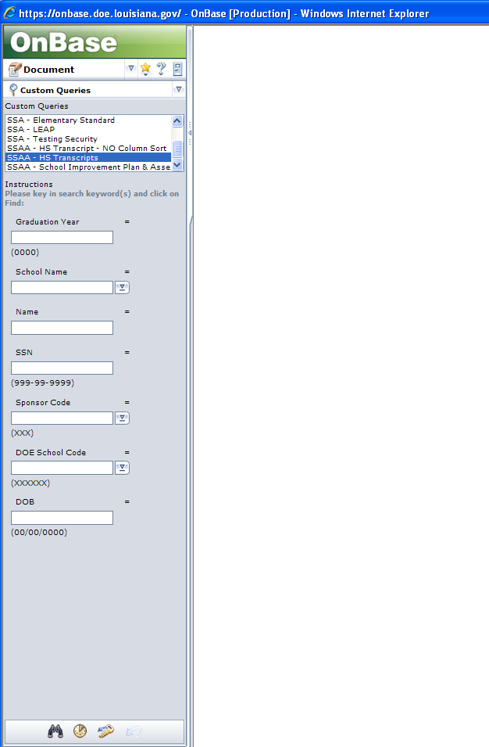

**Important Tips:**

1. Use a unique keyword of SSN to retrieve transcript first

2. If not found, use a wildcard search on school name or student’s name (example, search transcript for John Smith, key in “Smith, Jo*” in name as wildcard search to get a hit list and then double click on the selected student to see his/her transcript.

***(Don’t only use one keyword of graduation year, sponsor code, or DOB to get a hit list because the volume of transcripts for only using one of above keyword is too large to be listed on the screen)***